### 1. What will be the output of the following code?

var a = 10;  
if (true) {  
 var a = 20;  
}  
console.log(a);

* 1. 10
  2. 20 guess [correct]
  3. undefined
  4. Error

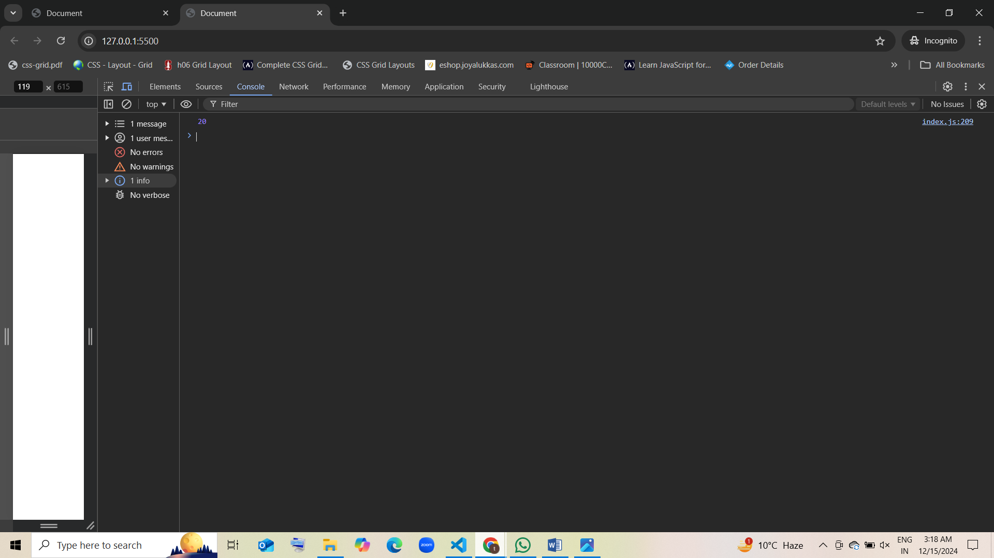

### 2. What will be the output of the following code?

let a = 10;  
if (true) {  
 let a = 20;  
}  
console.log(a);

* 1. 10 guess [correct]
  2. 20
  3. undefined
  4. Error

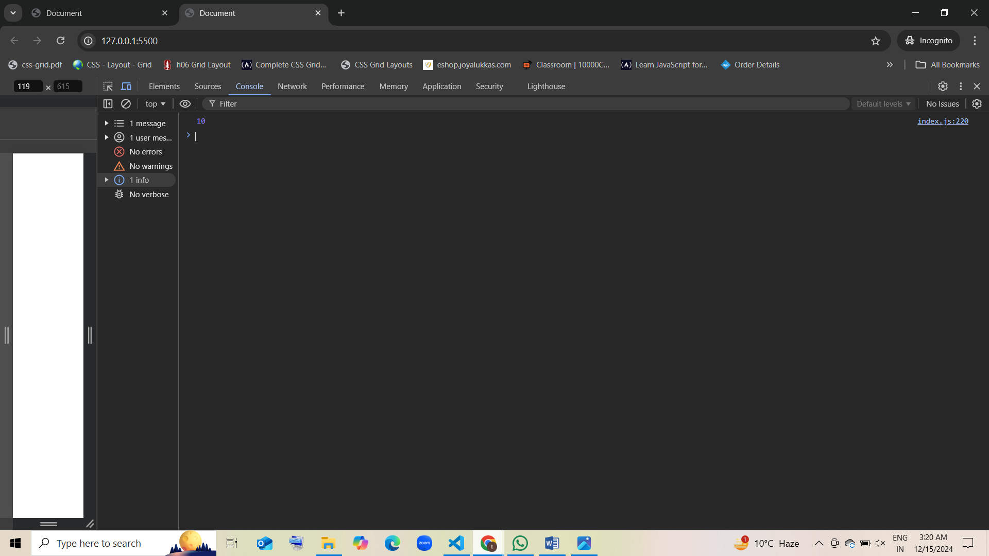

### 3. In the following code, which scope does the variable x belong to?

function foo() {  
 var x = 100;  
 if (true) {  
 let y = 200;  
 }  
}

* 1. Block scope
  2. Function scope
  3. Global scope
  4. Undefined

### 4. What will be the output of the following code?

const a = 5;  
{  
 const a = 10;  
 console.log(a);  
}  
console.log(a);

* 1. 5, 5
  2. 10, 5 guess [correct]
  3. 10, 10
  4. 5, 10

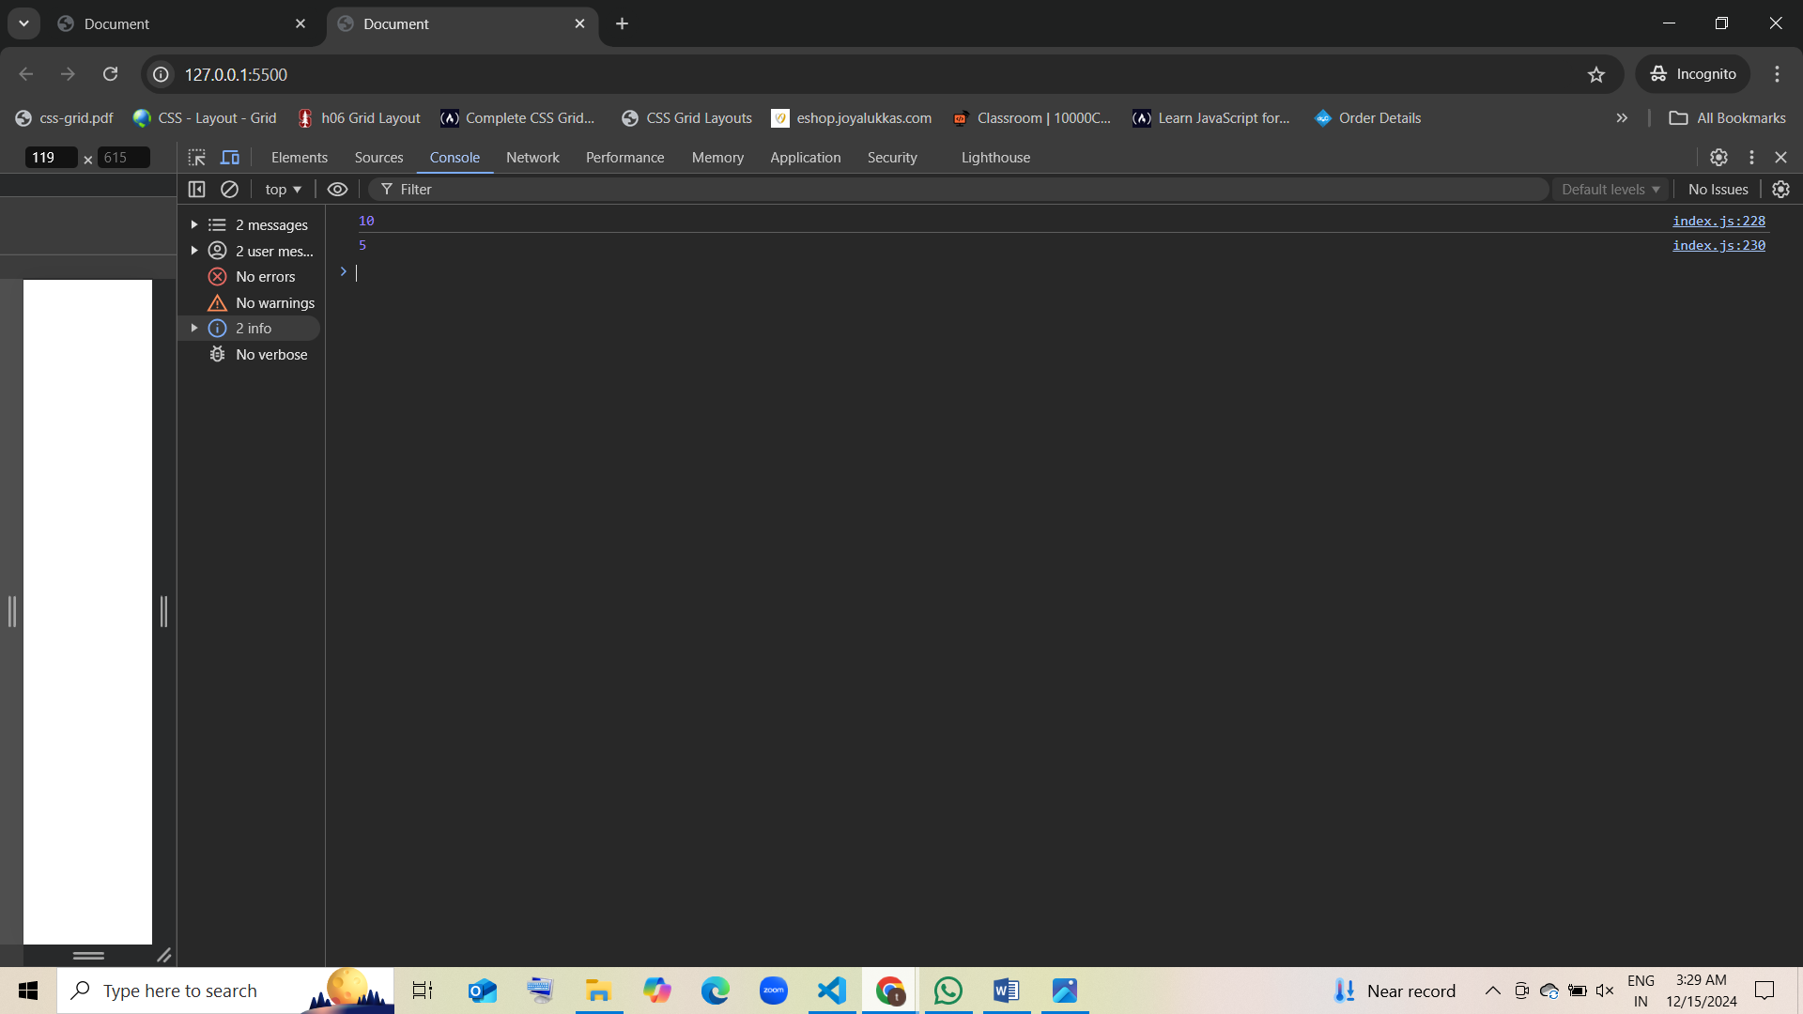

### 5. What will be the output of the following code?

var x = 1;  
function test() {  
 var x = 2;  
 if (true) {  
 var x = 3;  
 }  
 console.log(x);  
}  
test();

* 1. 1
  2. 2
  3. 3 guess [correct]
  4. Undefined

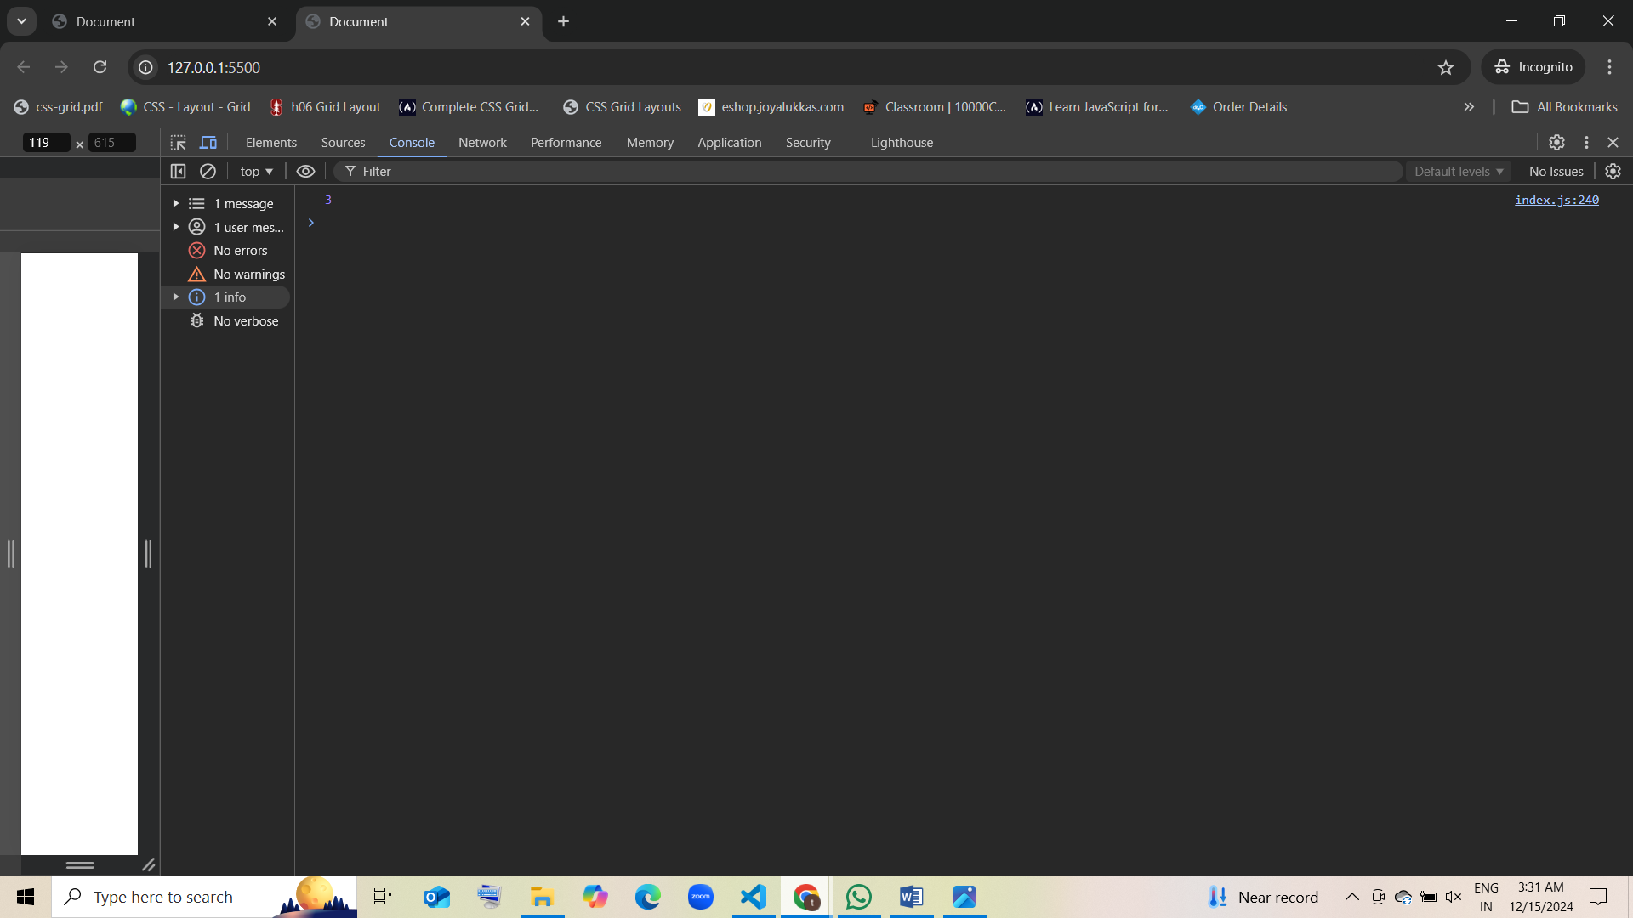

### 6. Which of the following statements about JavaScript variable scopes is correct?

* 1. Variables declared with var have block scope.
  2. Variables declared with let and const have block scope. Guess [correct]
  3. Variables declared with let have function scope.
  4. Variables declared inside functions have global scope.

### 7. What will be the output of the following code?

var x = 10;  
{  
 var x = 20;  
}  
console.log(x);

* 1. 10
  2. 20 guess [correct]
  3. undefined
  4. Error

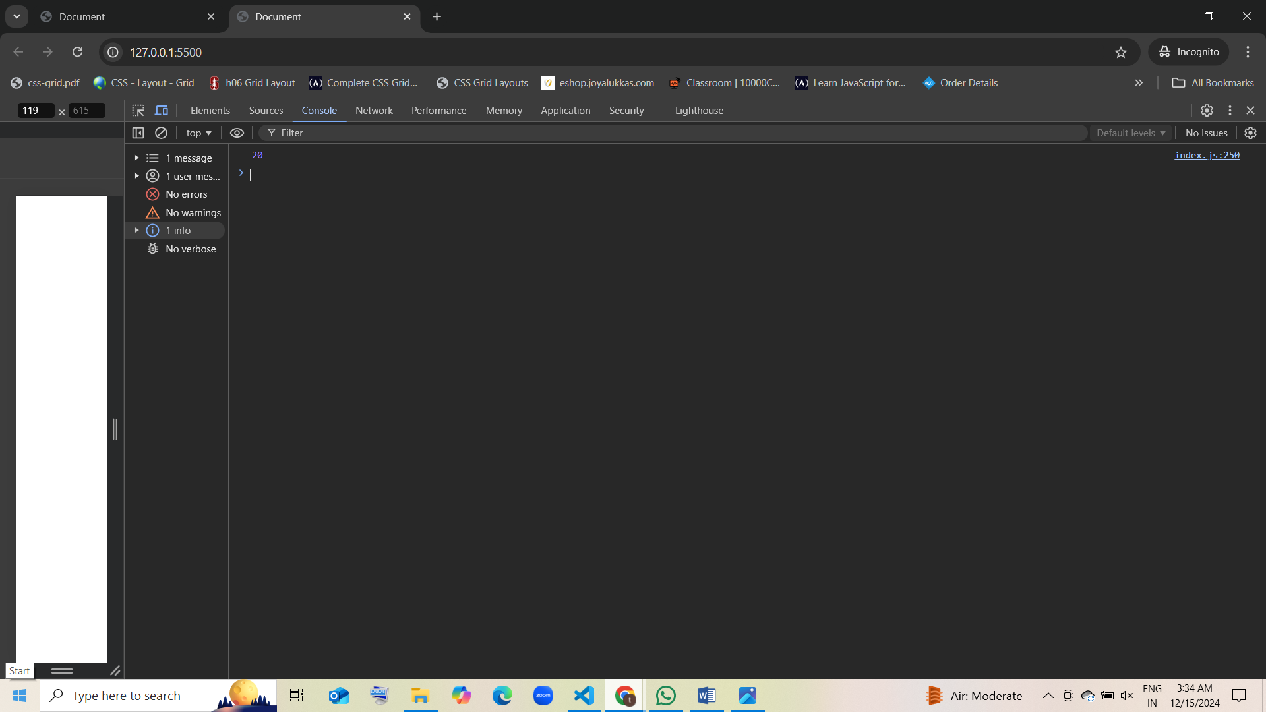

### 8. What is the output of the following code?

let a = 5;  
{  
 let a = 10;  
 console.log(a);  
}  
console.log(a);

* 1. 10, 10
  2. 10, 5 guess [correct]
  3. 5, 5
  4. 5, 10

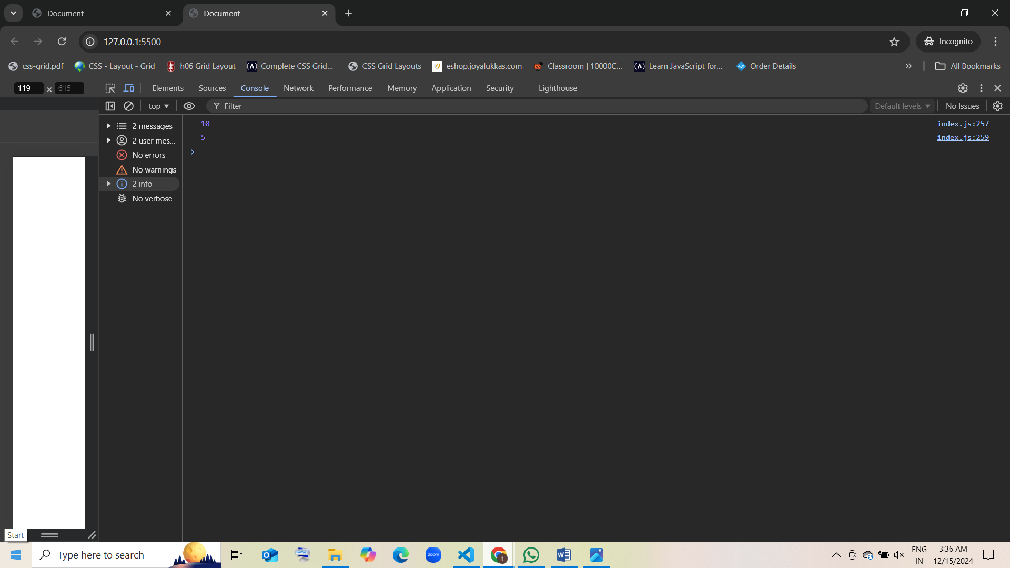

### 9. What is the scope of a variable declared with let inside a for loop?

for (let i = 0; i < 3; i++) {  
 console.log(i);  
}  
console.log(i);

* 1. Global scope
  2. Block scope guess [correct]
  3. Function scope
  4. Undefined

### 10. What is the scope of a variable declared with var inside a for loop?

for (var i = 0; i < 3; i++) {  
 console.log(i);  
}  
console.log(i);

* 1. Global scope
  2. Block scope
  3. Function scope [correct]
  4. Undefined

### 11. Which scope does the variable name have in the following code?

let name = "John";  
function greet() {  
 console.log(name);  
}  
greet();

* 1. Block scope
  2. Global scope guess [correct]
  3. Function scope
  4. Undefined

### 12. What is the result of the following code?

var x = 10;  
function test() {  
 var x = 20;  
 console.log(x);  
}  
test();  
console.log(x);

* 1. 20, 10 guess [correct]
  2. 10, 20
  3. 20, 20
  4. 10, 10

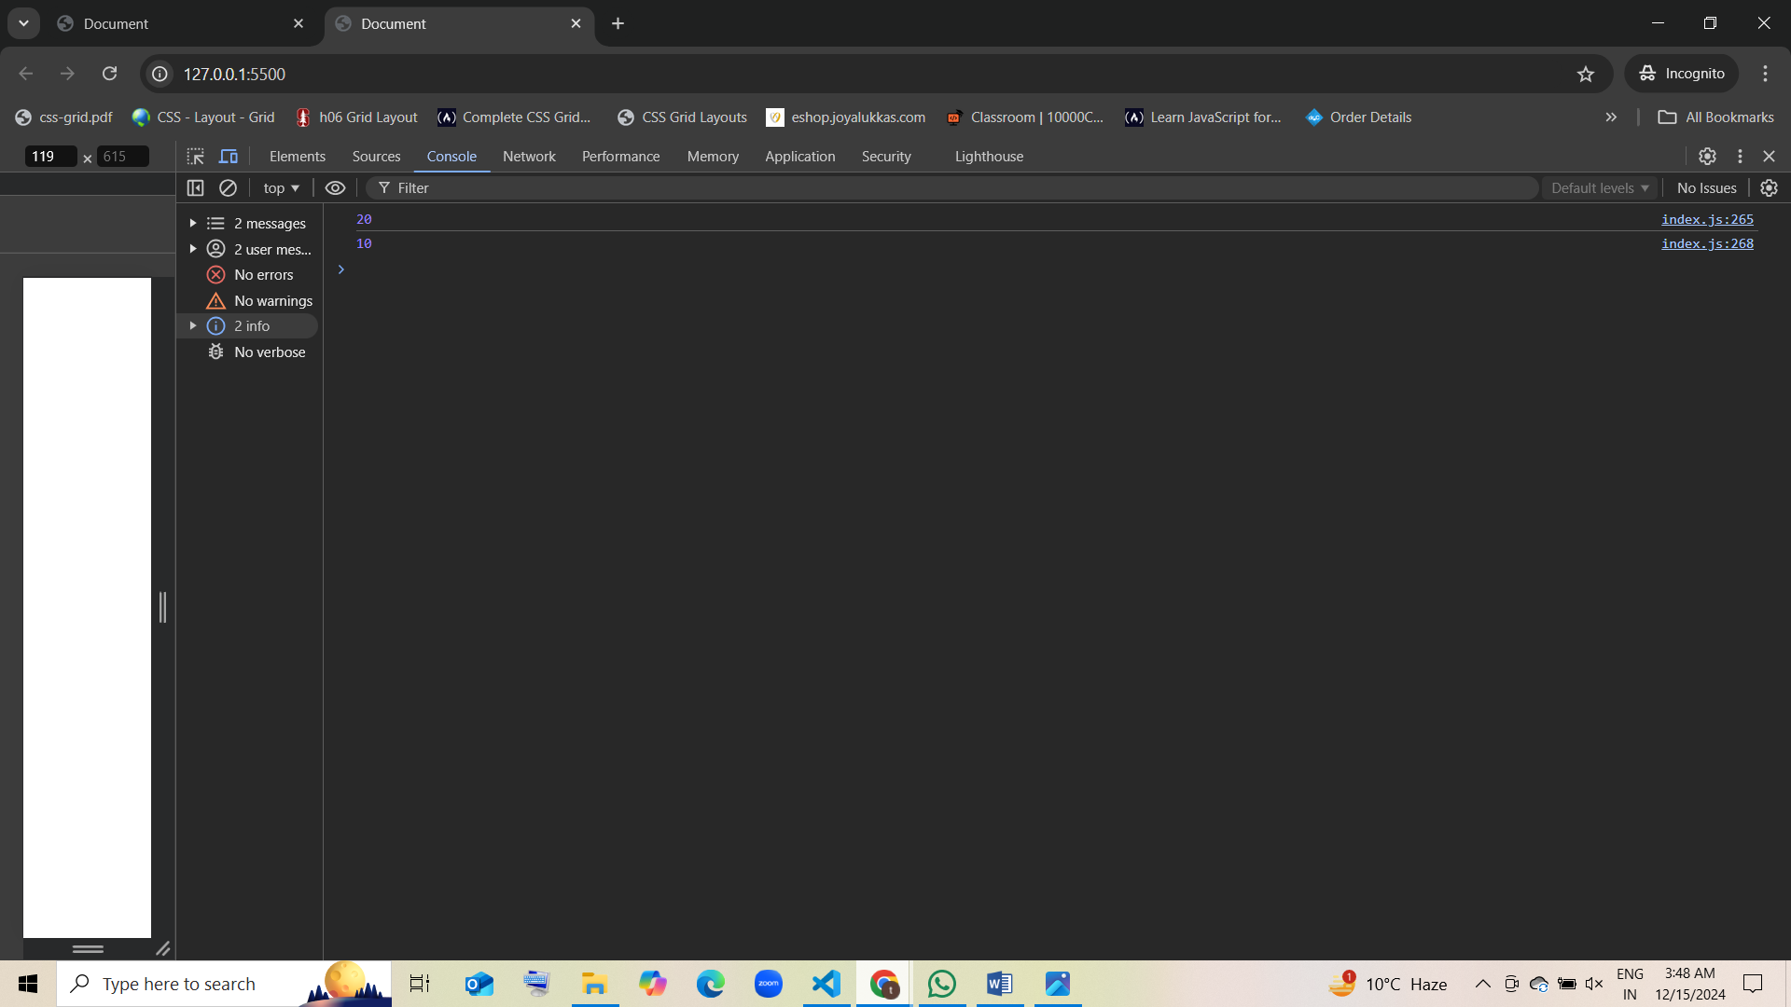

### 13. What will the following code output?

let x = 5;  
function outer() {  
 let x = 10;  
 function inner() {  
 let x = 15;  
 console.log(x);  
 }  
 inner();  
}  
outer();

* 1. 5
  2. 10
  3. 15 guess [correct]
  4. Error

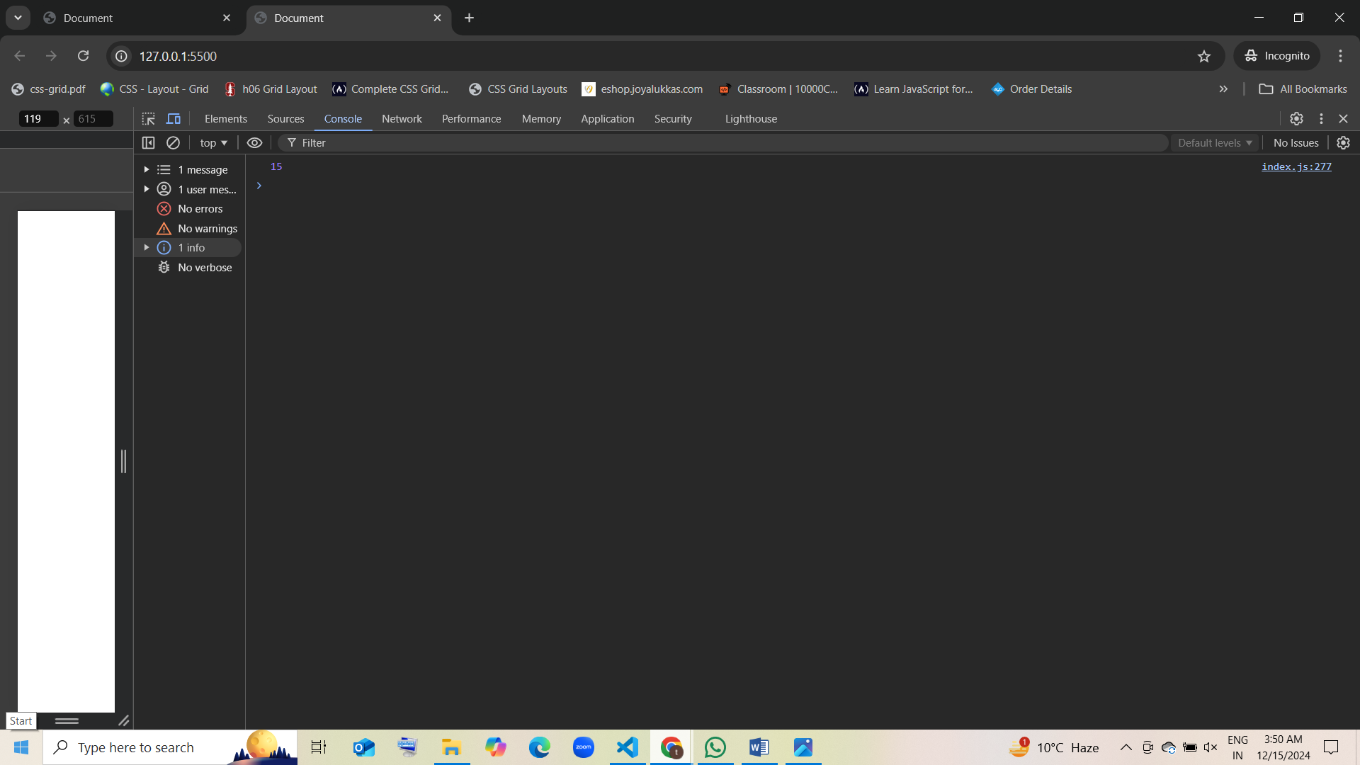

### 14. In which scope is the variable y accessible in the following code?

function test() {  
 let y = 30;  
 if (true) {  
 let y = 40;  
 }  
 console.log(y);  
}  
test();

* 1. Global scope
  2. Block scope
  3. Function scope guess [correct]
  4. Undefined

### 15. Which scope does the variable a have in the following code?

let a = 100;  
if (true) {  
 let a = 200;  
 console.log(a);  
}  
console.log(a);

* 1. Global scope, Block scope
  2. Block scope, Global scope [correct]
  3. Global scope, Global scope
  4. Block scope, Block scope

### 16. What will be the output of the following code?

var a = 5;  
function myFunction() {  
 if (true) {  
 var a = 10;  
 }  
 console.log(a);  
}  
myFunction();

* 1. 10 guess [correct]
  2. 5
  3. undefined
  4. Error

### 17. What will be the output of this code?

let x = 5;  
function outer() {  
 const x = 10;  
 function inner() {  
 console.log(x);  
 }  
 inner();  
}  
outer();

* 1. 5
  2. 10 guess [correct]
  3. undefined
  4. Error

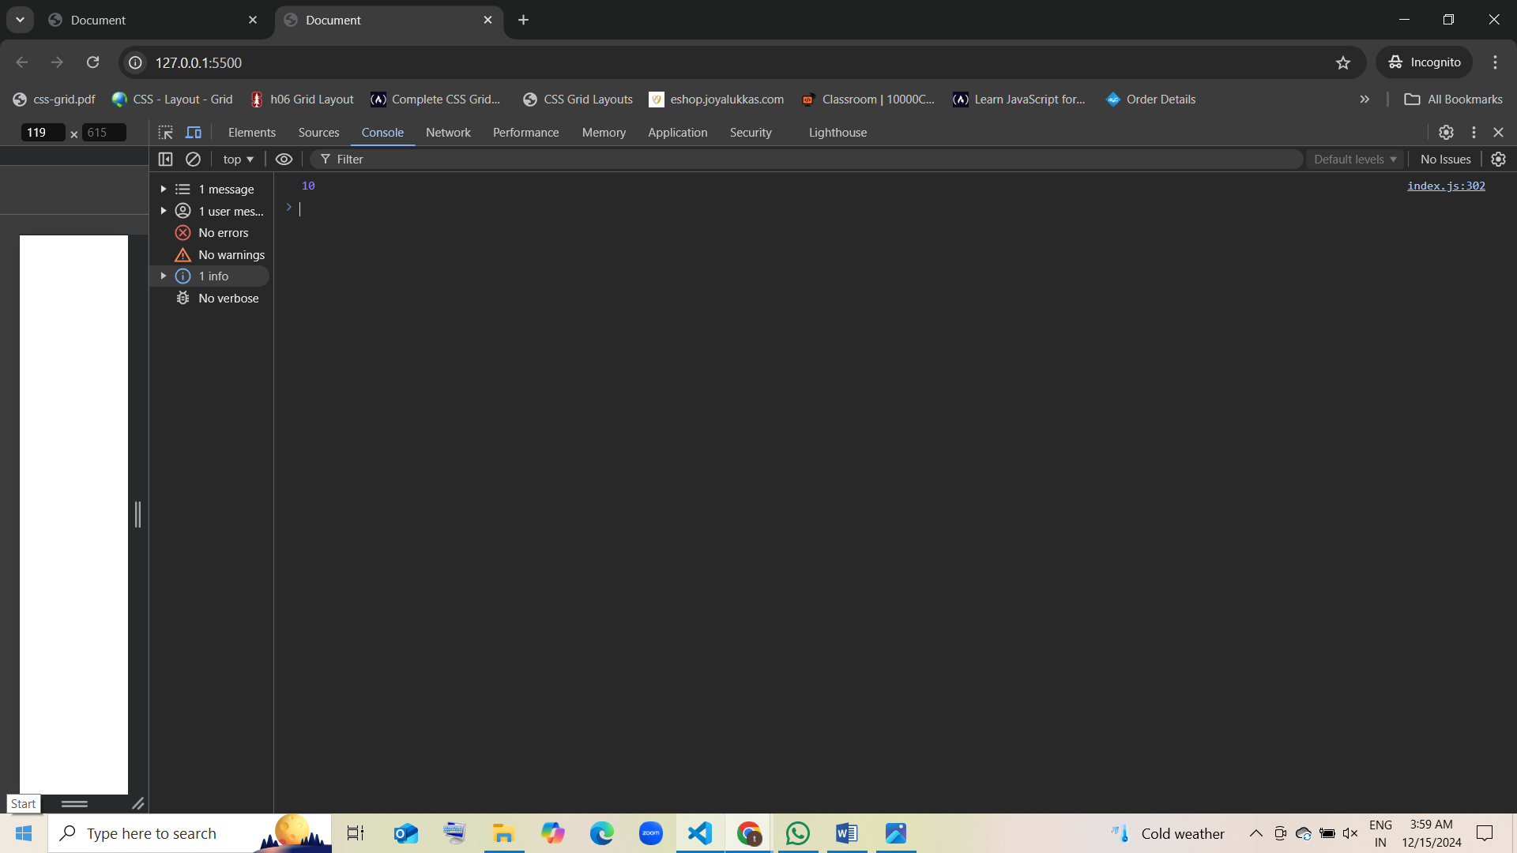

### 18. What is the scope of i in the following code?

for (let i = 0; i < 5; i++) {  
 console.log(i);  
}  
console.log(i);

* 1. Block scope guess[correct]
  2. Function scope
  3. Global scope
  4. Undefined

### 19. What is the scope of a variable declared with const inside a block?

{  
 const a = 10;  
 console.log(a);  
}  
console.log(a);

* 1. Block scope guess [correct]
  2. Global scope
  3. Function scope
  4. Undefined

### 20. What will the following code output?

let x = 100;  
{  
 const x = 50;  
 console.log(x);  
}  
console.log(x);

* 1. 100, 100
  2. 50, 100 guess [correct]
  3. 50, 50
  4. 100, 50

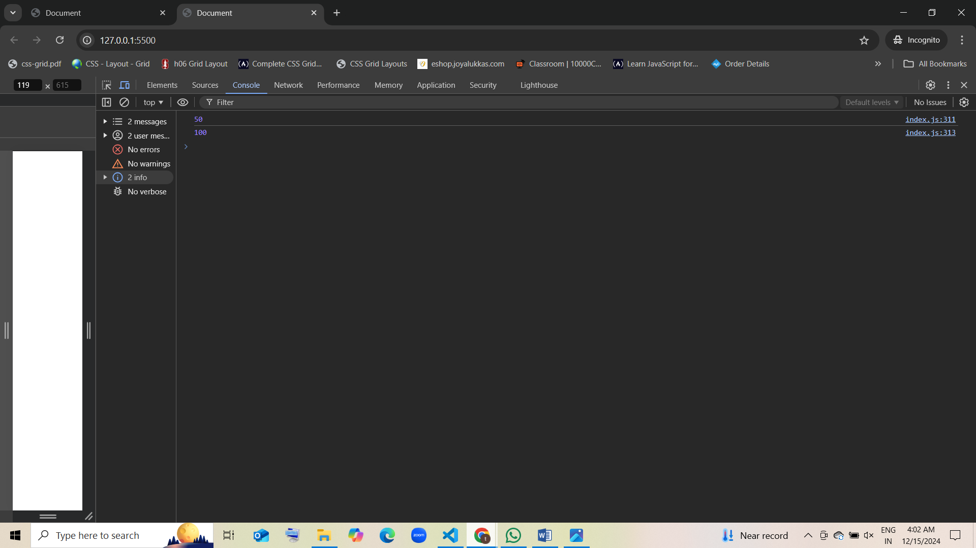

### 21. In the following code, where is the variable x accessible?

let x = "global";  
function test() {  
 let x = "function";  
 if (true) {  
 let x = "block";  
 console.log(x);  
 }  
}  
test();  
console.log(x);

* 1. Block scope, Function scope
  2. Global scope, Function scope [correct]
  3. Global scope, Block scope
  4. Block scope, Global scope

### 22. What will be the output of this code?

function test() {  
 var x = 1;  
 if (true) {  
 var x = 2;  
 console.log(x);  
 }  
}  
test();

* 1. 1
  2. 2 guess [correct]
  3. undefined
  4. Error

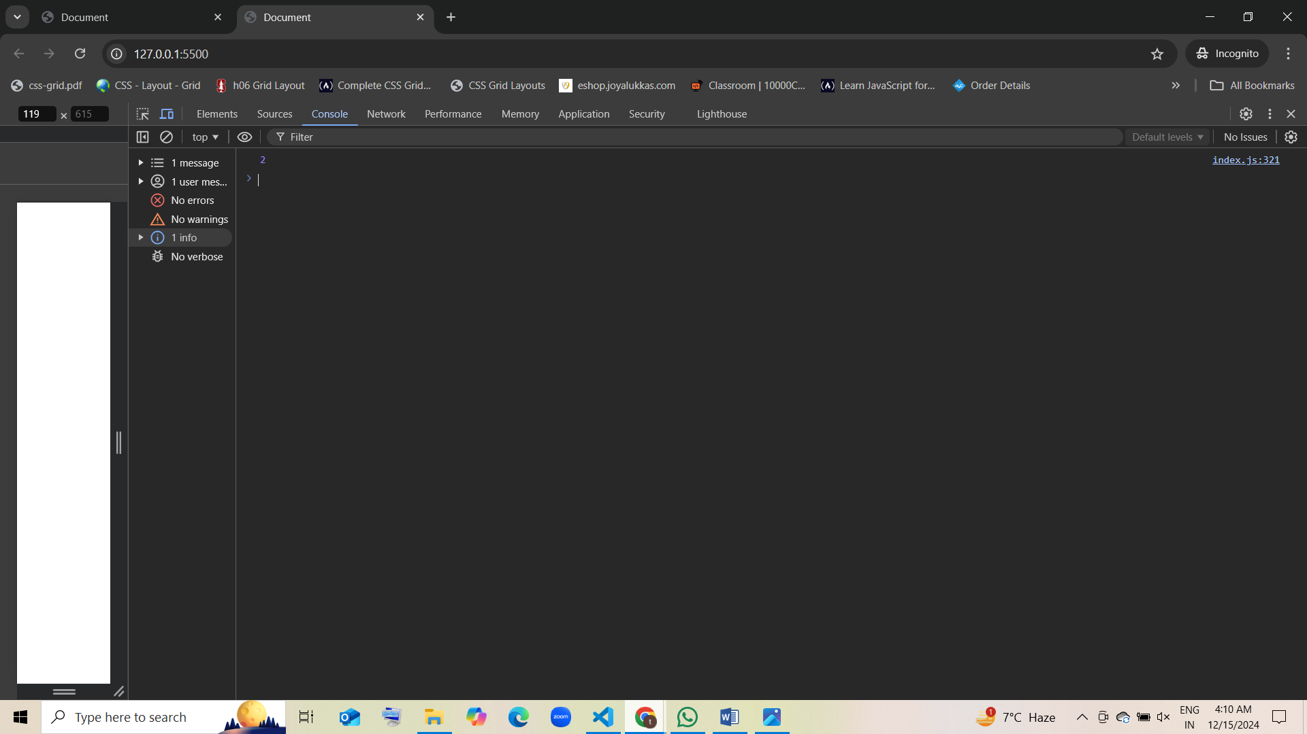

### 23. What is the scope of a variable declared inside a function?

function foo() {  
 let z = 30;  
}  
console.log(z);

* 1. Global scope
  2. Function scope guess [correct]
  3. Block scope
  4. Undefined

### 24. In which scope is the variable y in the following code?

let x = 100;  
if (true) {  
 let y = 200;  
 console.log(y);  
}

* 1. Block scope guess [correct]
  2. Global scope
  3. Function scope
  4. Undefined

### 25. Which of the following will result in an error?

let a = 5;  
const a = 10;

* 1. No error
  2. Syntax error [correct]
  3. Runtime error
  4. Reference error

### 26. What will be the output of this code?

function foo() {  
 let x = 20;  
 return function() {  
 console.log(x);  
 };  
}  
const bar = foo();  
bar();

* 1. undefined
  2. 20 [correct]
  3. Error
  4. ReferenceError

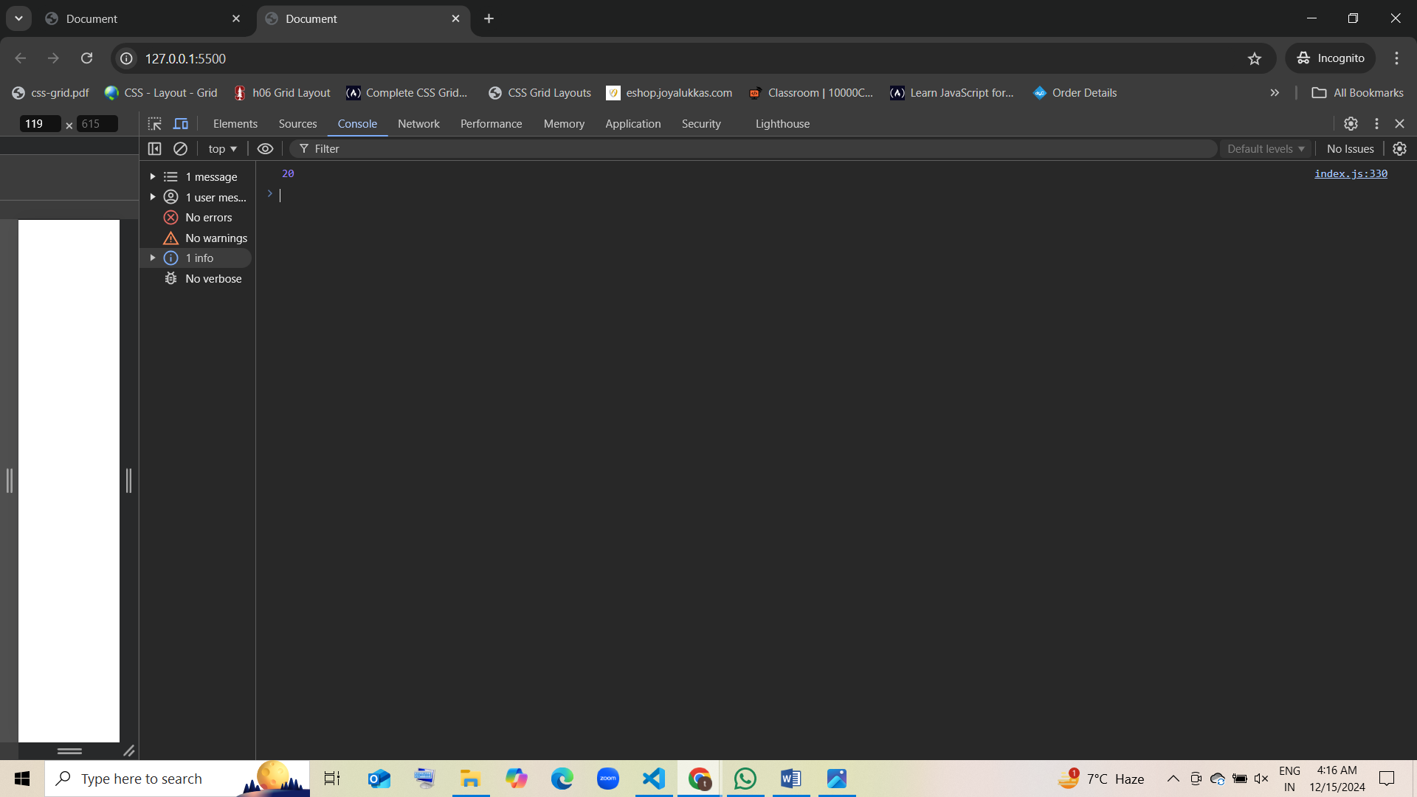

### 27. What will be the output of the following code?

{  
 let a = 10;  
 const b = 20;  
 console.log(a, b);  
}  
console.log(a, b);

* 1. 10, 20, 10, 20
  2. 10, 20, undefined, undefined
  3. 10, 20, Error [correct]
  4. 10, 20, undefined, ReferenceError

### 28. What is the result of this code?

let a = 10;  
function test() {  
 let a = 20;  
 {  
 let a = 30;  
 console.log(a);  
 }  
 console.log(a);  
}  
test();  
console.log(a);

* 1. 30, 20, 10 guess [correct]
  2. 30, 30, 10
  3. 30, 20, 20
  4. 30, 20, Error

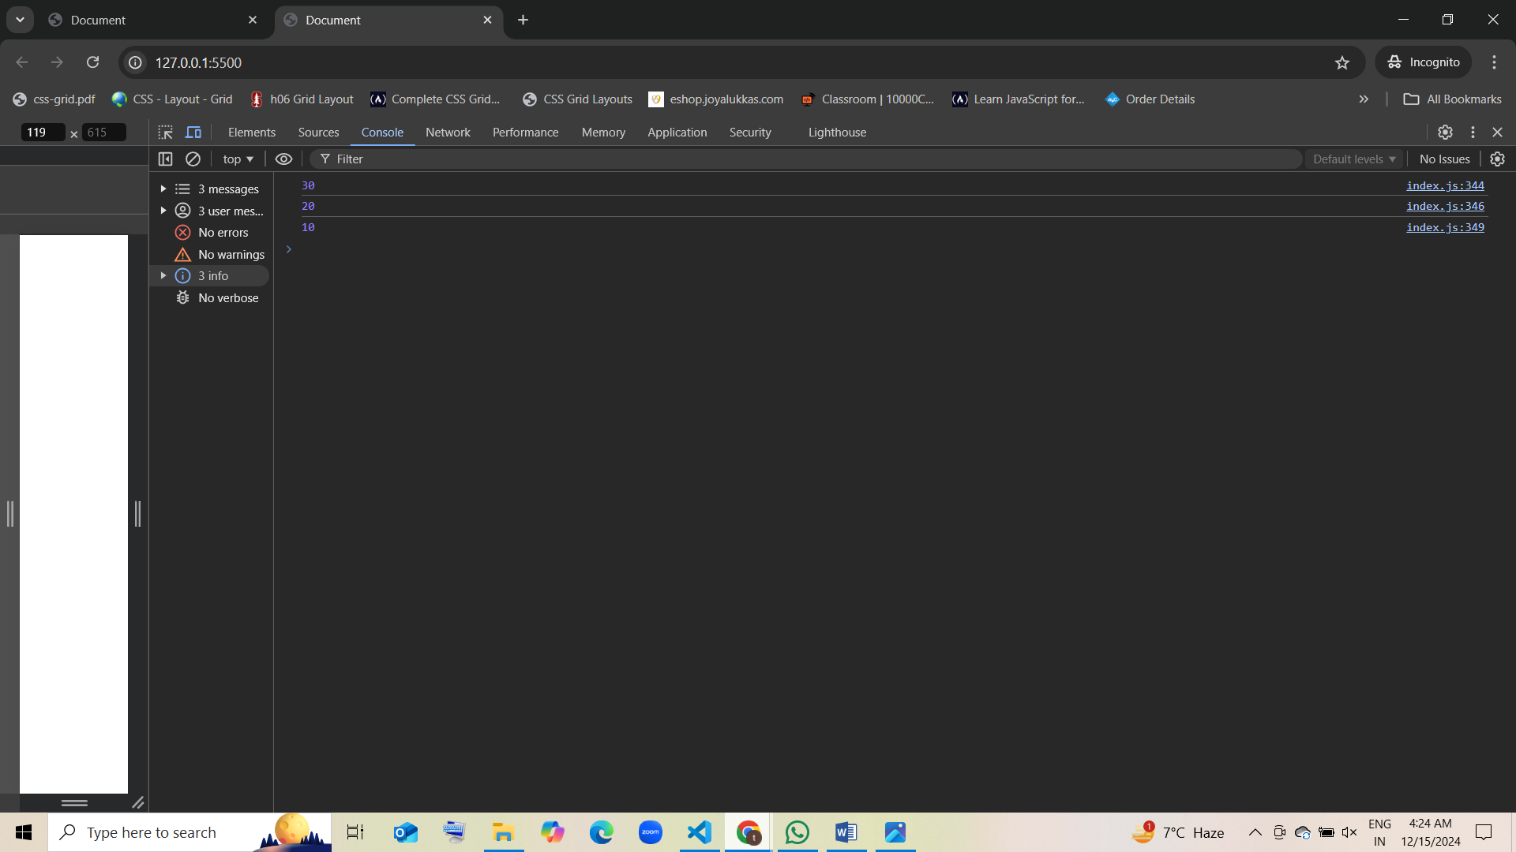

### 29. In which scope is the variable x available in the following code?

function outer() {  
 let x = 10;  
 {  
 let x = 20;  
 {  
 let x = 30;  
 console.log(x);  
 }  
 }  
}  
outer();

* 1. Global scope
  2. Function scope
  3. Block scope guess [correct]
  4. Undefined

### 30. What is the output of this code?

let x = 50;  
function test() {  
 let x = 100;  
 {  
 const x = 200;  
 console.log(x);  
 }  
 console.log(x);  
}  
test();  
console.log(x);

* 1. 200, 100, 50 guess [correct]
  2. 200, 100, Error
  3. 200, 200, 50
  4. 200, 100, 100

